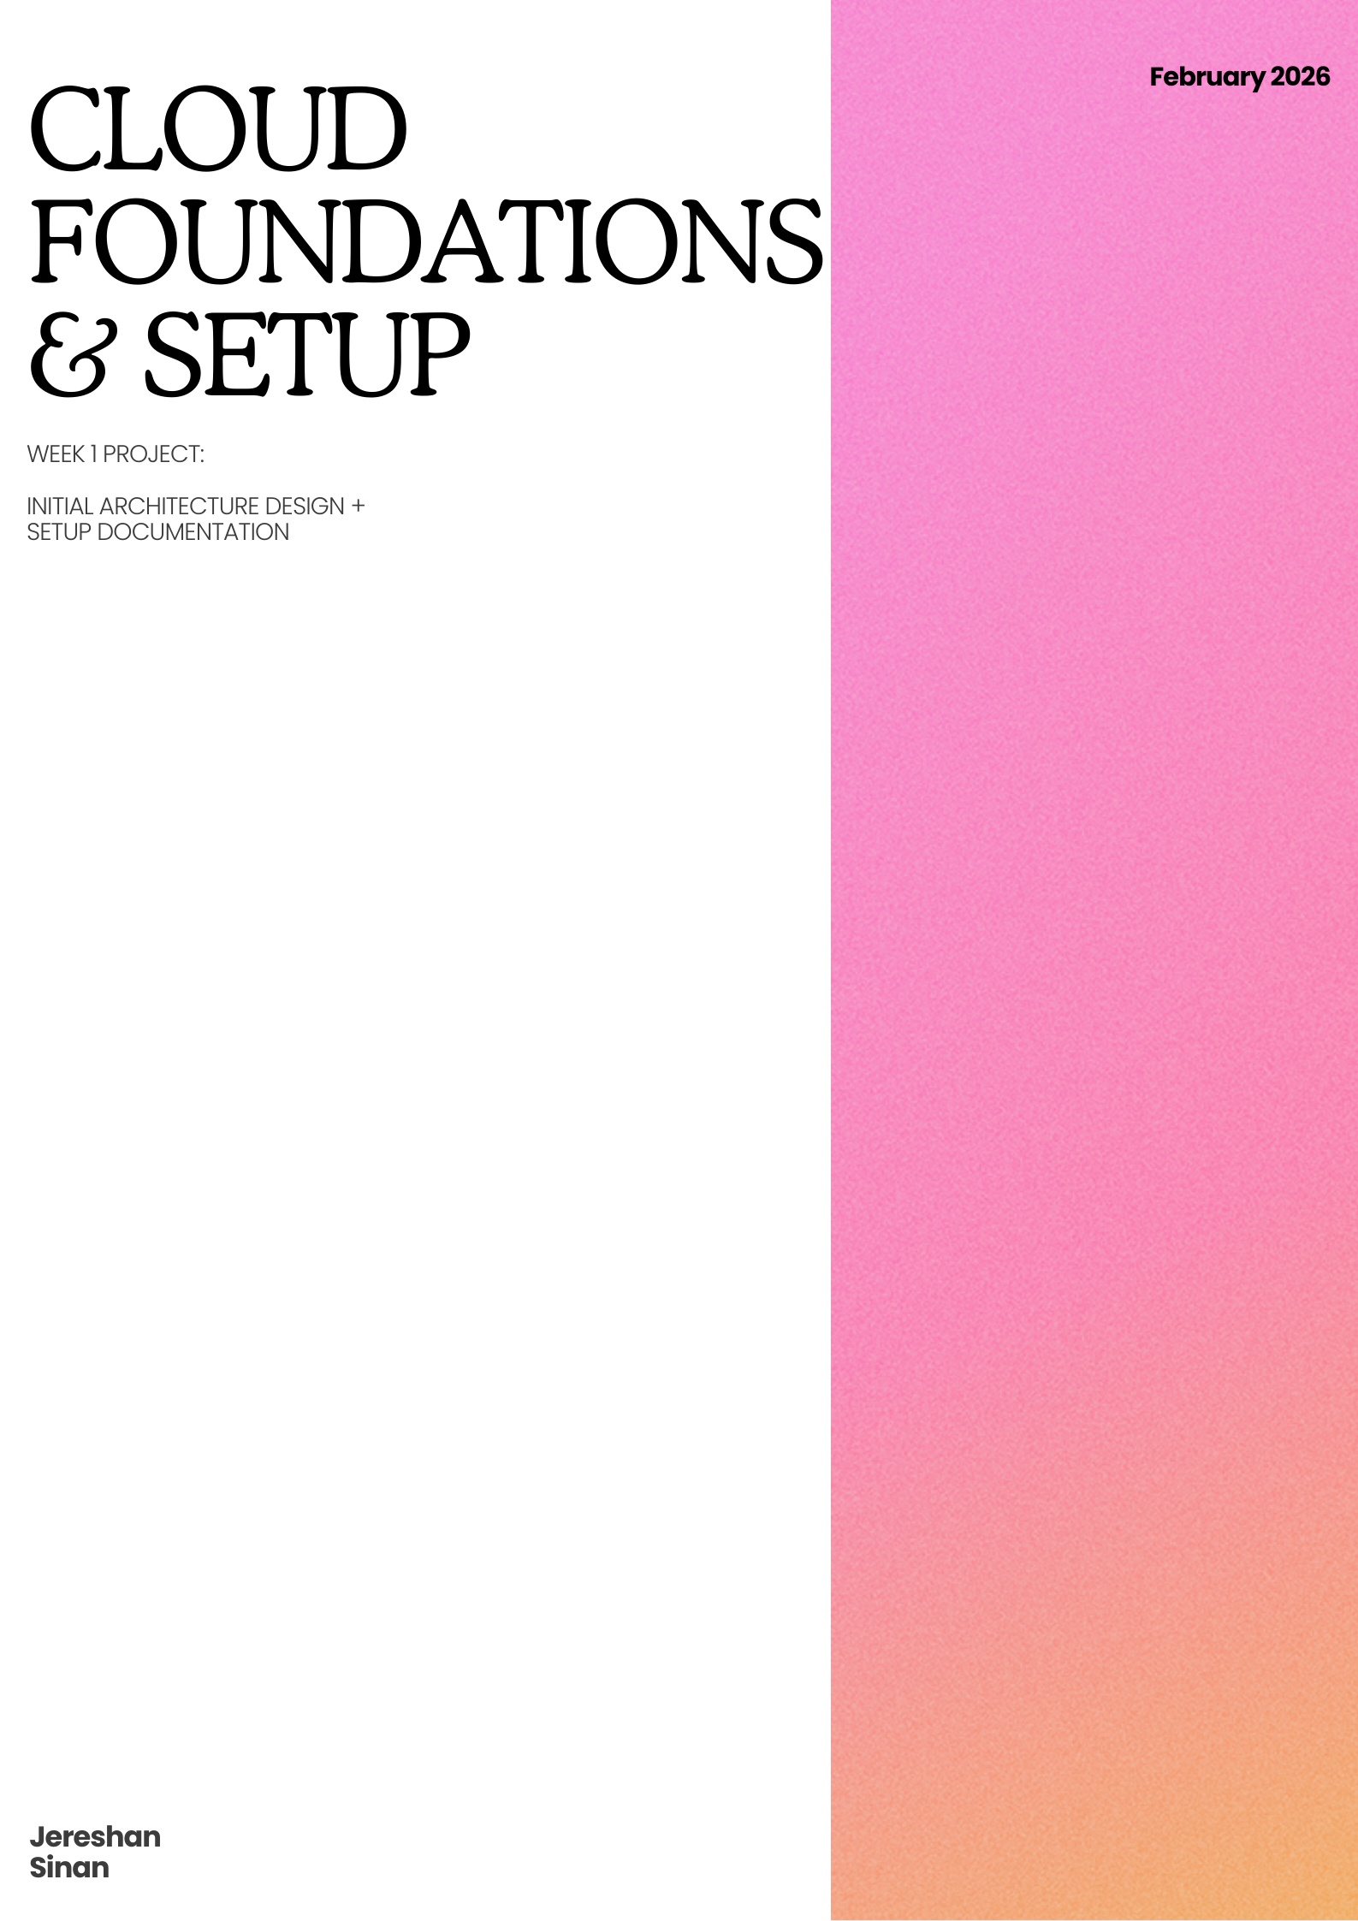

Table of Contents
1. AWS-To-Open-Source Mapping Table 3
2. Setup Documentation (Docker Environment) 3
2.1 Prerequisites 3
2.2 Core Service Commands 3
3. Cloud Simulation Architecture Diagram 4

1. AWS-To-Open-Source Mapping Table
AWS Service Domain | AWS Official Service | Local Open-Source Tool | Role in Your Banking System
Storage | Amazon S3 | MinIO | Object storage for banking assets (e.g., identity docs, PDF statements).
Database | Amazon DynamoDB | MongoDB | NoSQL store for flexible user metadata and session data.
Compute / API | AWS Lambda | FastAPI | Serverless-style logic handling banking transactions and user requests.
Networking | API Gateway | FastAPI / Uvicorn | Manages entry points for external requests to your banking services.

2. Setup Documentation (Docker Environment)

2.1 Prerequisites
- OS: Ubuntu 24.04 LTS (Running on dedicated SSD)
- Virtualization: VirtualBox with Guest Additions enabled
- Docker Engine: Installed and user added to docker group

2.2 Core Service Commands
Below are the exact commands used to initialize your simulation environment:
- MinIO (S3 Simulation - Dashboard: http://localhost:9001):
- MongoDB (Database Simulation):

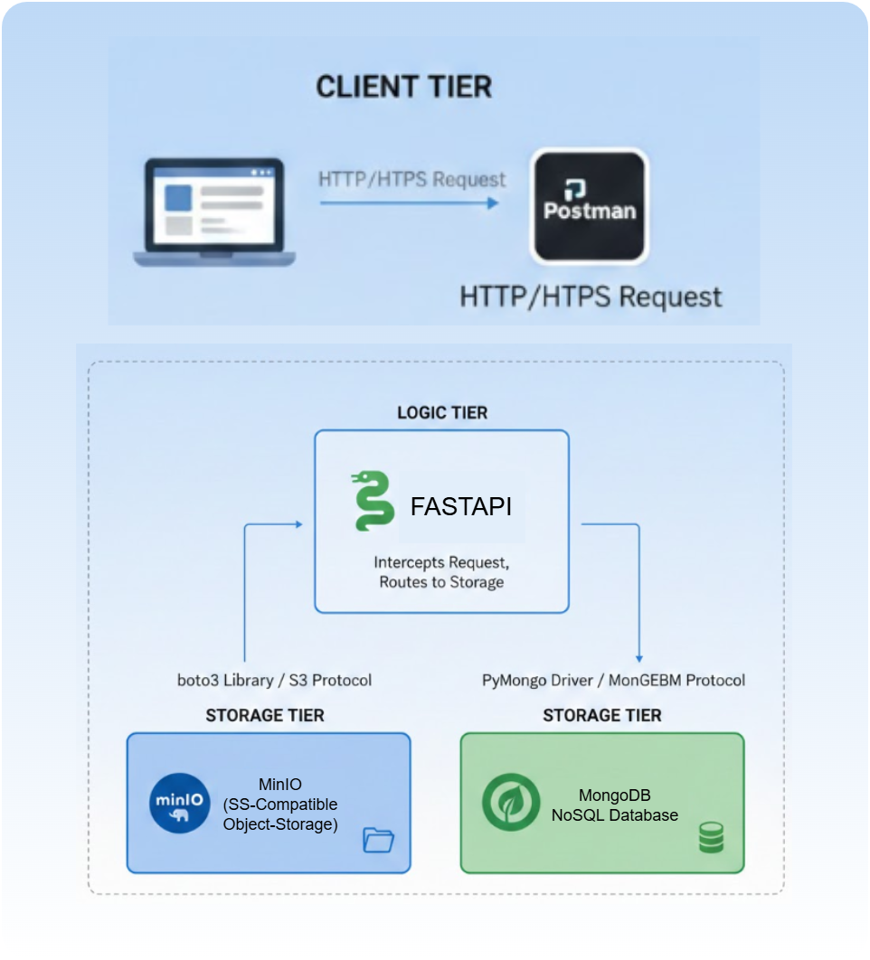
3. Cloud Simulation Architecture Diagram

